**Boston University**

**Electrical & Computer Engineering**

**EC463 Senior Design Project**

First Semester Report

Aerobatic BlackBox

Submitted to

Dr. Kenneth D. Sebesta

CyPi Ltd.

Address 1

Address 2

859-648-0272

[kenn@cypiltd.com](mailto:kenn@cypiltd.com)

by

Team 9

Team 9 Aerobatic BlackBox

Team Members

Xinyu Liu xinyubu@bu.edu

Pai Liu paiii@bu.edu

Wenjun Ma wjm123@bu.edu

Radhey K. Patel rexu6@bu.edu

Darcy Meyer darcym@bu.edu

Submitted: Dec 12, 2021

#### Table of Contents

Executive Summary ii

1.0 Introduction 1

2.0 Concept Development 2

3.0 System Description 3

4.0 First Semester Progress 4

5.0 Technical Plan 5

6.0 Budget Estimate 6

7.0 Attachments 7

7.1 Appendix 1 – Engineering Requirements 7

7.2 Appendix 2 – Gantt Chart 8

7.3 Appendix 3 – Other Appendices 9

***(right click on Table of Contents to update fields and page numbers automatically)***

# Executive Summary

Project Title

Team 9 – Aerobatic BlackBox

What is nature of the problem?

What will be your final deliverable?

What is your proposed technical approach?

What are any innovative features?

*(This should be written for management/public dissemination.*

*This will be published and distributed to ECE faculty.)*

# Introduction

This section brings the reader into your proposal by setting the stage for the detailed information that follows. Your white paper assignment (HW10) should have developed much of the material for this section.

Describe succinctly WHAT THE CUSTOMER'S PROBLEM IS.

Introduce any general information that the reader may need to understand your project.

State the purpose of your team’s project; in the context of the customer's problem.

State the general approach of your team

Explain how your approach will solve user's problem/needs

Present highlights or special features of your project.



Figure 1. This compass is an embedded figure. A brief explanatory caption should accompany each figure. Every figure should be numbered.

***(Not more than 2 pages, less figures.***

***Figures may be embedded in text, or appended at end of text.).***

***Refer to figures in text as ‘Fig. 1’, etc.***

# Concept Development

Here you describe your analysis of the customer’s problem and its translation into specific engineering terms. You should address:

* your engineering understanding of the customer’s problem,
* the conceptual approach you have chosen to solve the problem, and

You must reduce the customer’s needs to a small number of engineering requirements. You must identify those requirements as a ***1-page attachment, Appendix 1***

Elaborate on the conceptual approach for your project. Explain briefly why you chose your proposed concept, and mention one or two of the alternative solutions you considered and abandoned.

***(This section should be 2-3 pages)***

***You MUST include a 1 page Requirements list as Appendix 1.***

# System Description

Here you describe in technical detail WHAT YOU WILL PROVIDE as a solution. It should be as detailed, specific, quantitative, and engineering-oriented as possible.

Avoid grand promises and vague descriptions. Ruthlessly edit collective, vague adjectives and claims (e.g. “We will have high power and long life in our nuclear transmitter”). Follow the concept you are recommending from section 2.

You MUST include a system block diagram (approximately a level 2 functional decomposition) for your system/software, including a brief narrative explanation. The system block diagram should identify clearly the major subsystem blocks. Directed arrows should represent data or control flows. It is appropriate to use a full page for the system block diagram, and to import a figure developed in another application, e.g. Visio.) The following was done in Word Draw.



Figure 2. Block diagram of the Beam Transporter.

If appropriate, include a discussion of the user interface with your preliminary GUI. You can sketch the project or include a photo of your mockup.

If it is a software project, you should include high-level pseudocode of how the project will operate.

***(This section should be 2-3 pages. It is an overview description.)***

# First Semester Progress

This section is a detailed summary of the progress your team has made this semester. Include key results from your First Deliverable Testing.

# Technical Plan

Describe how you plan to complete your proposed solution.

The performance period of this plan is December 11, 2012 – May 1, 2013. You should not discuss tasks that are already completed or plans that are in the past! Remember the functional testing of your project is the week of April 1 (This is when the project is “due”)

Organize this section as a discussion of tasks and milestones, integrated with your professionally prepared Gantt Chart (Appendix 2)

Tasks should be clearly named. They should be described with a verb-an action word. They should have a clear, measurable deliverable product at their completion.

*Task 2. Battery power supply*

*A 3V, 200 mA battery power supply shall be designed, fabricated and tested. It shall be rechargeable from an external connector and meet specifications for weight, battery life, and heat dissipation. The design should be tested with a dummy load of 900 ohms. Lead: Captain Kirk; Assisting: Scottie.*

***(No more than 4 pages.)***

# Budget Estimate

In this section you discuss WHAT ARE THE BUDGET IMPLICATIONS AND CONSTRAINTS for your effort.

| **Item** | **Description** | **Cost** |
| --- | --- | --- |
| 1 | Photon source | $200 |
| 2 | Galactic stabilizer | $130 |
| 3 | Wire wrap supplies | $5 |
|  | Total Cost | $335 |

A short narrative discussion should elaborate on any unusual or dominating budget items. If you plan to obtain important components from the customer, professors, or as a possible vendor donation, please mention it here.

This should include major items, and estimated costs. Donated items should be shown with cost, and a note made that the item is to be donated.

Budgets are not guessing games. Do not make up numbers, or group items so much that details are hidden (e.g. “Miscellaneous electronics $200”). Such guesswork gets projects and companies in trouble.

Most projects should have only one page for budget.

# Attachments

# Appendix 1 – Engineering Requirements

Team # Team Name:

Project Name:

| **Requirement** | **Value, range, tolerance, units** |
| --- | --- |
| Case dimensions | 2m x 2m x 1.4m |
| Power | 1GJ photon source, and 3V battery |
| Transport range | >100 light years |
| Transport nodes | 3 in simplex mode (no return possible);  2 in duplex mode (round trip stored) |
| Radiation dose | 20 REM/trip +1 REM, -3 REM |
| Transport error rate | < 10-11 molecules of normal body mass  < 10-15 molecules when sending DNA data |

These are your requirements specifications that transform the customer’s needs and wants into specific engineering requirements. See the course textbook regarding the formation of appropriate specifications. Generally these are at the system integration level. Each unit that you design will have its own internal specifications, but these are usually not listed in a proposal.

Specifications should not include vague environmental constraints.

Specifications should not be statements of technology preferences or early design decisions (e.g. “The unit shall use Li ion batteries” is not a specification.)

Not more than one page.

# Appendix 2 – Gantt Chart

Here you provide a STANDARD PRESENTATION OF THE TASKS, MANAGEMENT, AND SCHEDULE of your efforts. You can access MS Project to create a professional Gantt Chart and cut and paste the chart here. (This template was done MS Project and saved to Word. Remember: Clear date headers; dependencies; milestones; hierarchical tasks; course milestones.

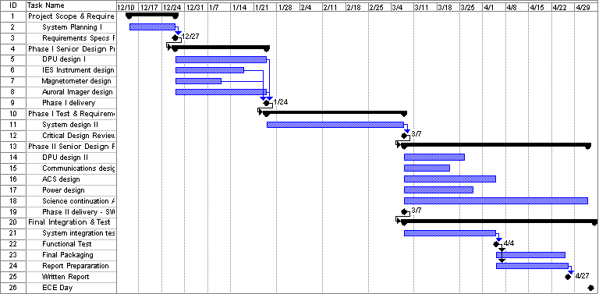

You need not include other MS Project columns like start and end dates, durations, support, etc. Make major milestones clear.

# Appendix 3 – Other Appendices

Other typical attachments that are added to bolster the competitiveness of your proposal:

* Technical references (in proper bibliographic form) including key URLs.
* Your drawings and schematics (rather than embedding in text)
* Team information sheet (Biographical paragraph on each member; phone numbers and e-mail, history of team and company)

Do not pad with mundane data sheets and application notes.

**Spell Check Everything!!!!**

**Paginate and edit footers and headers for your team.**

**Work through at least two drafts before submitting final document.**

**DO NOT bind, put in fancy covers or otherwise embellish. Simply clip with spring binder in upper left corner.**

**Use MS Word or PDF format for final document.**

**Submit one soft copy to course via Blackboard Digital Drop Box, and one copy to customer (include cover letter to customer).**

***The body of the proposal should not exceed 20 pages.***

***(This excludes the cover page, table of contents, executive summary, and attachments.)***